Home Learning Term 1
Complete one home learning task each week and upload a picture to Google Classroom.
Geography – Biomes  • Make a 3D model of a biome (forest or aquatic)  • Design an animal or plant that could live in either a forest or aquatic biome  • Create a kit list of equipment that an explorer would need to explore either a forest or aquatic.  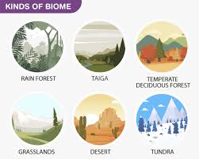 | Geography – Biomes  • Make a 3D model of a biome (forest or aquatic)  • Design an animal or plant that could live in either a forest or aquatic biome  • Create a kit list of equipment that an explorer would need to explore either a forest or aquatic.  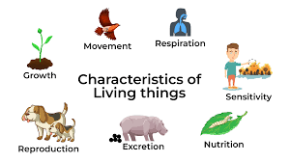 | English – Narrative & Non-Chronological report  Write a short story (about 1/2 to 1 page) imagining you are a child living during World War  1.You can choose:  -A child in Britain whose parent has gone to war  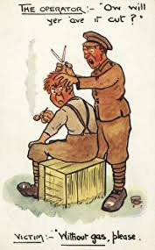  -A child helping in their village during wartime  -A child who finds an old letter or object from the war | Maths and Geography – Investigation  • Investigate the size of the two biomes we are focusing on in Year 5. How large or small are the environments, temperature differences. What facts can you find out about the two biomes?  
Maths and Spelling  • Ed Shed - EdShed - Educational products for spelling, phonics, literacy and maths  Have a go and the place value games on Maths Shed. Investigate the tious, ious and cious spellings.  • TTRS - https://play.ttrockstars.com/a uth/school/ student/  Can you improve your speed? Can you get to Rock Hero?  • Maths – please find attached a place value workbook, your child can work through. | Mindfulness  Go for a nature walk with your family and observe your surroundings. What five things can you see that you can’t normally? What four things can you hear? What three things can you feel? What two things can you smell? What one thing can you taste?   | History – World War One  • Research the historical facts about WW1 – dates, countries involved etc.  • Find out when poppy wearing begun – why was the poppy chosen as symbol of remembrance?  • Design a war memorial – this could be 3D or on Roblox, present it how you would like.  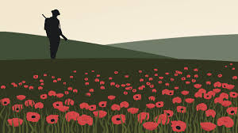 | Art – Banksy  • Is graffiti art or vandalism? Discuss with your adults at home – what do they think?  • Create your own tag! How will you write your name in graffiti style?  • Can you recreate, in your own way, a Banksy street art picture.  